“**Edit payments allocations**” screen:

It’s Excel-like screen which will be user-friendly manipulation window where collectors can see open payments which they can filter according to their needs. List contains both automatically identified payments and also rest of the payments which need input of AR analyst. Look of Excel as inspiration is intentional due to the fact that users are most familiar with this program and we’d like to expand its features which will be tailored for Lenovo.

Every cell in top row needs to have dropdown list / combo box for filtering of items according to user’s preference (ideally similar to Excel functionality, also with “Contains filter”).

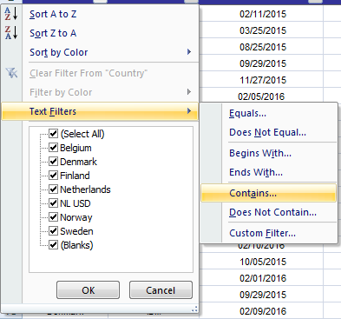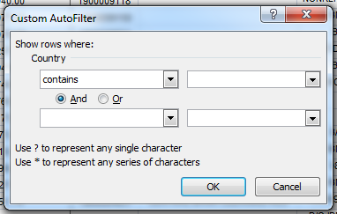

**1 Country & 2 Collector** - combo box with list of countries and collector names respectively

**3 Payment numbers** - total number of payments (Total); currently filtered payments (Filtered); payments where found/inserted invoices are matching with paid value (Matched); payments without any inserted invoices or comments (Without comments)

**4 Highlighted “Payment value” cell** - value will be highlighted if sum of automatically found invoices is matching with total payment value (either extracted from Payment details information or only one combination was found).

**5 Highlighted “Payment details” cell** - string will be highlighted if sum of extracted invoices from “Payment details” information is matching with total payment value - highlighted payment value and payment details indicates successful extraction of invoices provided with customer and correct amount of monies received

**6 Highlighted “Payment value” cell** (distinguished from item no. 4) - value will be highlighted if sum of invoices inserted by collector is matching with total payment value - indicates successful input from AR analyst

**7 “Add/Edit” input button** - every payment will have button for manual input from AR analyst which will launch separate screen - exact functionality/design to be determined

**8 Count** - total number of invoices currently assigned with payment line (if 0, could be highlighted)

**9 Highlighted “Payment details” cell** (distinguished from item no. 5) - found open invoice in payment details however value of document is lower than payment value (list is most likely incomplete)

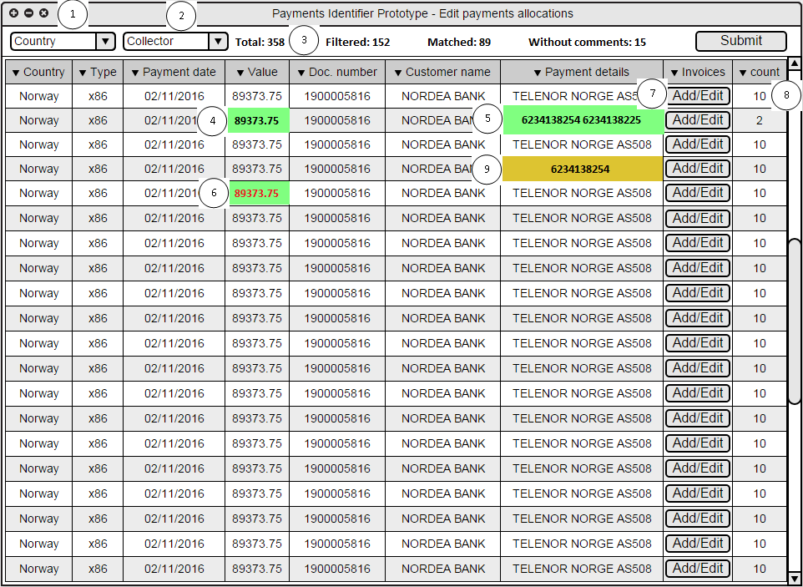

“**Insert AR input**” screen:

It is screen which is displayed to user when clicked on Add/Edit button in main window with unallocated payments (currently called “Edit payments allocations”). Its purpose is to provide user friendly space where user can provide his/her input for payments which weren’t matched automatically or were matched only partially. Whereas main window comprises from unallocated report data, “Insert AR input” window is comprised also with Daily report data (currently outstanding invoices) and user input.

**1 Payment combo box** - with useful information about the payment (originated from unallocated report)

Shape -> payment number | customer name | payment value

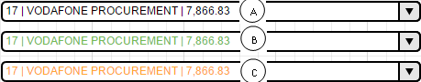

A standard payment without any input or any match found

B matched payment (could be also distinguished cases where matched manually vs. matched automatically - similar to main window logic - points 4 and 5)

C partially matched payment - only part of invoices were entered and there is still difference left to match

**2 previous/next payment buttons** - should omit matched (green) payments when changing payment. If user wants to select such payment, he/she can do so via combo box

**3 Save button** - effectively exit button, since payments are expected to be edited automatically (when user changes payments or with any other action)

**4 Details summary for selected payment** - data will be used from unallocated report (basically same type of data as in main window, albeit just for one specific payment)

**5 Number of documents** - total number of inserted documents

**6 Total value of invoices** - sum of found/entered invoices

A payment value not matching with entered invoices - amount left in brackets (alternatively can be solved in different way, perhaps separate text box in middle called “Value difference: 555”)

B payment value matching with entered/found invoices

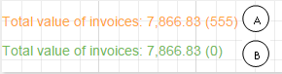

**7 list of invoices** - will be found both automatically and also entered manually by user - ideally column Invoice no. will be directly editable - possibility to delete cell, insert text into it or copy the text into clipboard. Other columns will only have “copy to clipboard” functionality or completely disabled interactivity (data for these columns used from Daily report database).

**8 Collector’s commentary** - especially for cases when collector is not able to close payment with specific invoices by himself/herself - e.g. “investigating with customer”

***9 bank fees and penny elimination*** *- will be used only when big version of software is approved for development*

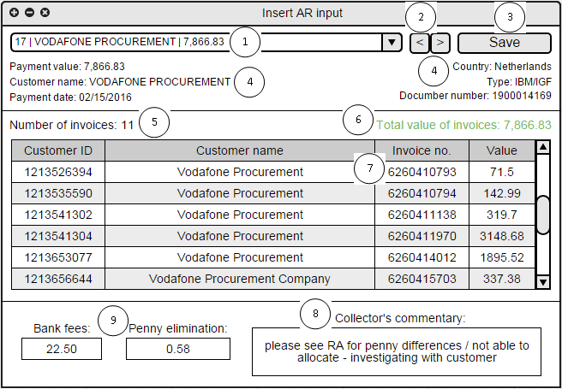

“**Customers database**” screen:

This screen’s purpose is to pair unallocated sender name strings with specific customer IDs which belong to them. It is one of main conditions in order to get automatic matching of invoices working. Screen is triggered from main window of application and it serves as more convenient tool for editing program’s “.config” file instead of Notepad. Other advantage is implementation of control mechanisms which check that proper data were inserted by user.

**1 Country** - user writes (preferably selects) supported country. If country name is wrong / not supported - error message must be displayed and input rejected as invalid.

**2 Sender’s customer name** - name of bank account holder which issued payment to Lenovo (By Order/Beneficiary column in unallocated reports)

**3 Customer ID** - sold-to number associated with sender’s name. There can be more than one sold-to (customer ID) entered by user.

Note: don’t forget to define logic how input should be processed - numbers divided e.g. by semicolon, space, comma, etc. Also, validity check that sold-to starts with 12_ and it’s 10-digit number should be implemented as well.

**4 collector name** - user writes (preferably selects) one of existing collector’s accounts *(applicable only for big version of software). If collector’s name is wrong / is not supported - error message must be displayed and input rejected as invalid.*

Note: Collector’s name is not mandatory field, it can be unassigned. However, I would recommend highlighting unassigned items.

